1. What are the different margins options and do we adjust the margins of the excel worksheet?

To use predefined margins, click Normal, Wide, or Narrow and To specify custom page margins, click Custom Margins and then—in the Top, Bottom, Left, and Right boxes—enter the margin sizes that you want ,not usually we adjust the margin of the excel worksheets.

2. Set a background for your table created.

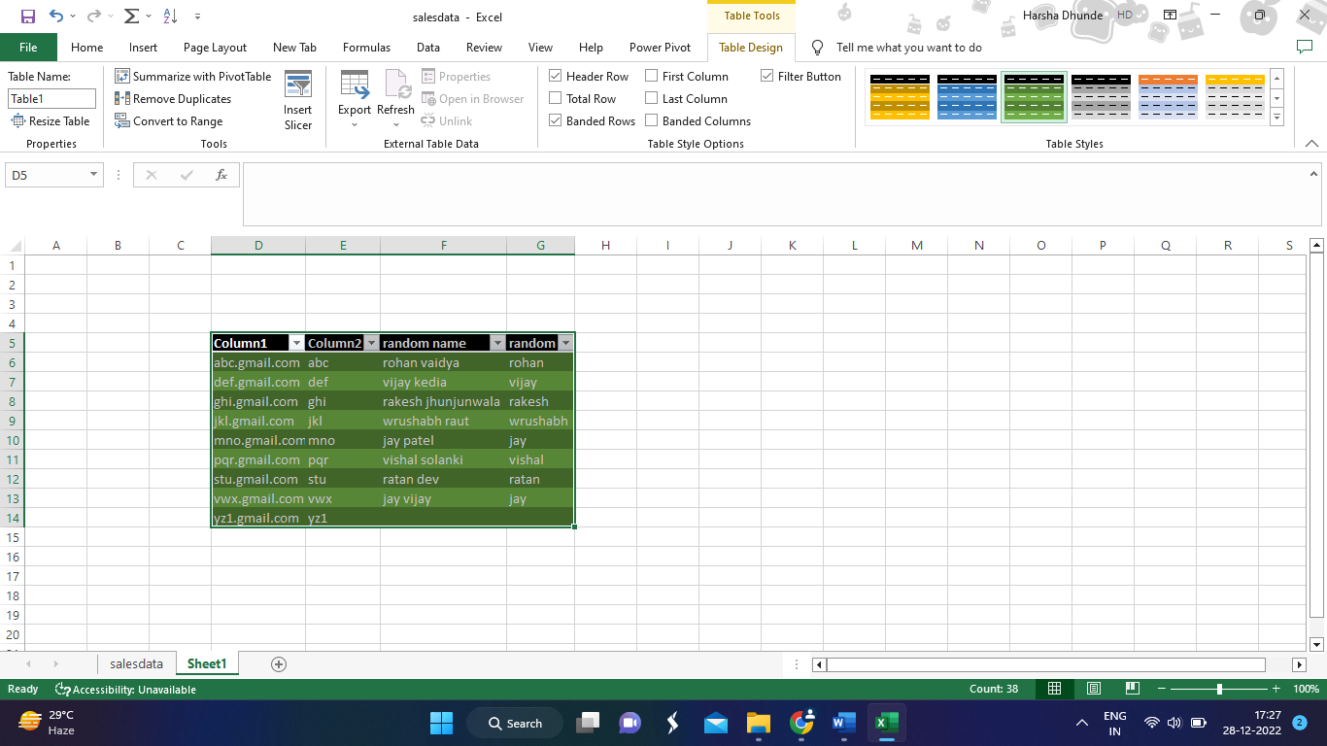 click here to change background colurs

3. What is freeze panes and why do we use freeze panes? Give examples.

When we freeze panes, Excel keeps specific rows or columns visible when we scroll in the worksheet. For example, if the first row in our spreadsheet contains labels, we might freeze that row to make sure that the column labels remain visible as we scroll down in our spreadsheet

To keep an area of a worksheet visible while we scroll to another area of the worksheet, go to the View tab, where we can Freeze Panes to lock specific rows and columns in place, or we can Split panes to create separate windows of the same worksheet.

**How to Freeze Top Row?**

1. Go to View tab > Windows group > Freeze First Column.
2. Select Freeze First Column.

**How to Freeze First Column?**

You can freeze only the first column for your worksheet by following these steps:

1. Go to View tab > Windows group > Freeze First Column.
2. Select Freeze First Column.

4.What are the different features available within the Freeze Panes command?

To keep an area of a worksheet visible while we scroll to another area of the worksheet, go to the View tab, where we can use Freeze Panes to lock specific rows and columns in place, or we can Split panes to create separate windows of the same worksheet.

* Freeze pane. ...
* Freeze Top row. ...
* Freeze First column.

5. Explain what the different sheet options present in excel are and what they do?

* Ribbon Sheet Options
* Right-click Sheet Options

### **Ribbon Sheet Options**

Some quick sheet options are also present on the Excel ribbon and can be accessed by going to **Page Layout > Sheet Options.**

### **Right-click Sheet Options**

In Excel, the right-click with mouse button usually displays the context menu for the selected element. When we press the right-click on any Sheet tabs, Excel displays a list of options relevant to Excel sheets.